Missing Birth_Order Analysis Report
Generated: 2026-03-22 16:55
Dataset: 301,712 rows × 18 columns
Target Variable: Birth_Order

1. Executive Summary
This report presents a comprehensive IUPAC-compliant statistical analysis of missing values in Birth_Order.
Key findings include:
• Missing records: 26,007 (8.6% of total data)
• Variables with significant differences (p < 0.05): 13
- Numeric variables: 4
- Categorical variables: 9
• Total variables analyzed: 17
Based on the statistical analysis, the missingness pattern is classified as:
SYSTEMATIC PATTERN - Missing data is strongly associated with other variables, suggesting non-random missingness.

2. Statistical Summary
Metric | Value
Total Missing Birth_Order Records | 26,007
Missing Percentage | 8.62%
Total Variables Analyzed | 17
Numeric Variables | 7
Categorical Variables | 10
Variables with Significant Differences (p < 0.05) | 13
Analysis Date | 2026-03-22

3. Variables with Significant Differences (p < 0.05)
The following 13 variables show statistically significant differences between missing and complete groups:

3.1 Numeric Variables
Variable | Missing Group Mean | Complete Group Mean | Difference | p-value | Interpretation
Birh_Year | 2019.05 | 2019.70 | -0.66 | 0.0000 | Missing group has 0.66 units lower than complete group
Birth_Month.0 | 6.51 | 6.58 | -0.07 | 0.0018 | Missing group has 0.07 units lower than complete group
Birth_Weight(grams) | 2941.07 | 2917.21 | +23.86 | 0.0004 | Missing group has 23.86 units higher than complete group
Age of Mother | 31.23 | 29.47 | +1.75 | 0.0000 | Missing group has 1.75 units higher than complete group

3.2 Categorical Variables
Variable | Missing Group Distribution | Complete Group Distribution | Difference (%) | p-value | Interpretation
Registered_Month | Most common='August' (12.3%) | Complete: Most common='June' (11.5%) | +0.8% | 0.0000 | Missing group shows different distribution (p=0.0000)
Registered_District | Most common='Ampara' (30.7%) | Complete: Most common='Colombo' (14.2%) | +16.5% | 0.0000 | Missing group shows different distribution (p=0.0000)
Birth_Month | Most common='August' (10.7%) | Complete: Most common='May' (9.1%) | +1.6% | 0.0000 | Missing group shows different distribution (p=0.0000)
Hospital or Not | Most common='Hospital' (99.0%) | Complete: Most common='Hospital' (99.8%) | -0.8% | 0.0000 | Missing group shows different distribution (p=0.0000)
Multiple_Birth_Status | Most common='missing' (99.6%) | Complete: Most common='missing' (98.9%) | +0.7% | 0.0000 | Missing group shows different distribution (p=0.0000)
Marital_Status | Most common='Married' (95.6%) | Complete: Most common='Married' (98.1%) | -2.5% | 0.0000 | Missing group shows different distribution (p=0.0000)
District_of_Mother | Most common='Ampara' (30.3%) | Complete: Most common='Colombo' (8.9%) | +21.4% | 0.0000 | Missing group shows different distribution (p=0.0000)
Race_of_Mother | Most common='Srilankan Tamil' (38.4%) | Complete: Most common='Sinhalese' (73.6%) | -35.2% | 0.0000 | Missing group shows different distribution (p=0.0000)
Race_of_Father | Most common='Srilankan Tamil' (38.1%) | Complete: Most common='Sinhalese' (73.8%) | -35.6% | 0.0000 | Missing group shows different distribution (p=0.0000)

3.3 Summary of Key Findings
The analysis identified 13 variables with statistically significant differences (p < 0.05):
• 4 numeric variables show significant mean differences
• 9 categorical variables show significant distribution differences
Top 10 Most Significant Variables:
1. Registered_Month: Most common='August' (12.3%) vs Complete: Most common='June' (11.5%) (p=0.0000)
2. Registered_District: Most common='Ampara' (30.7%) vs Complete: Most common='Colombo' (14.2%) (p=0.0000)
3. District_of_Mother: Most common='Ampara' (30.3%) vs Complete: Most common='Colombo' (8.9%) (p=0.0000)
4. Race_of_Mother: Most common='Srilankan Tamil' (38.4%) vs Complete: Most common='Sinhalese' (73.6%) (p=0.0000)
5. Race_of_Father: Most common='Srilankan Tamil' (38.1%) vs Complete: Most common='Sinhalese' (73.8%) (p=0.0000)
6. Birh_Year: Mean=2019.05 vs Complete Mean=2019.70 (p=0.0000)
7. Marital_Status: Most common='Married' (95.6%) vs Complete: Most common='Married' (98.1%) (p=0.0000)
8. Hospital or Not: Most common='Hospital' (99.0%) vs Complete: Most common='Hospital' (99.8%) (p=0.0000)
9. Birth_Month: Most common='August' (10.7%) vs Complete: Most common='May' (9.1%) (p=0.0000)
10. Multiple_Birth_Status: Most common='missing' (99.6%) vs Complete: Most common='missing' (98.9%) (p=0.0000)

4. Statistical Visualizations
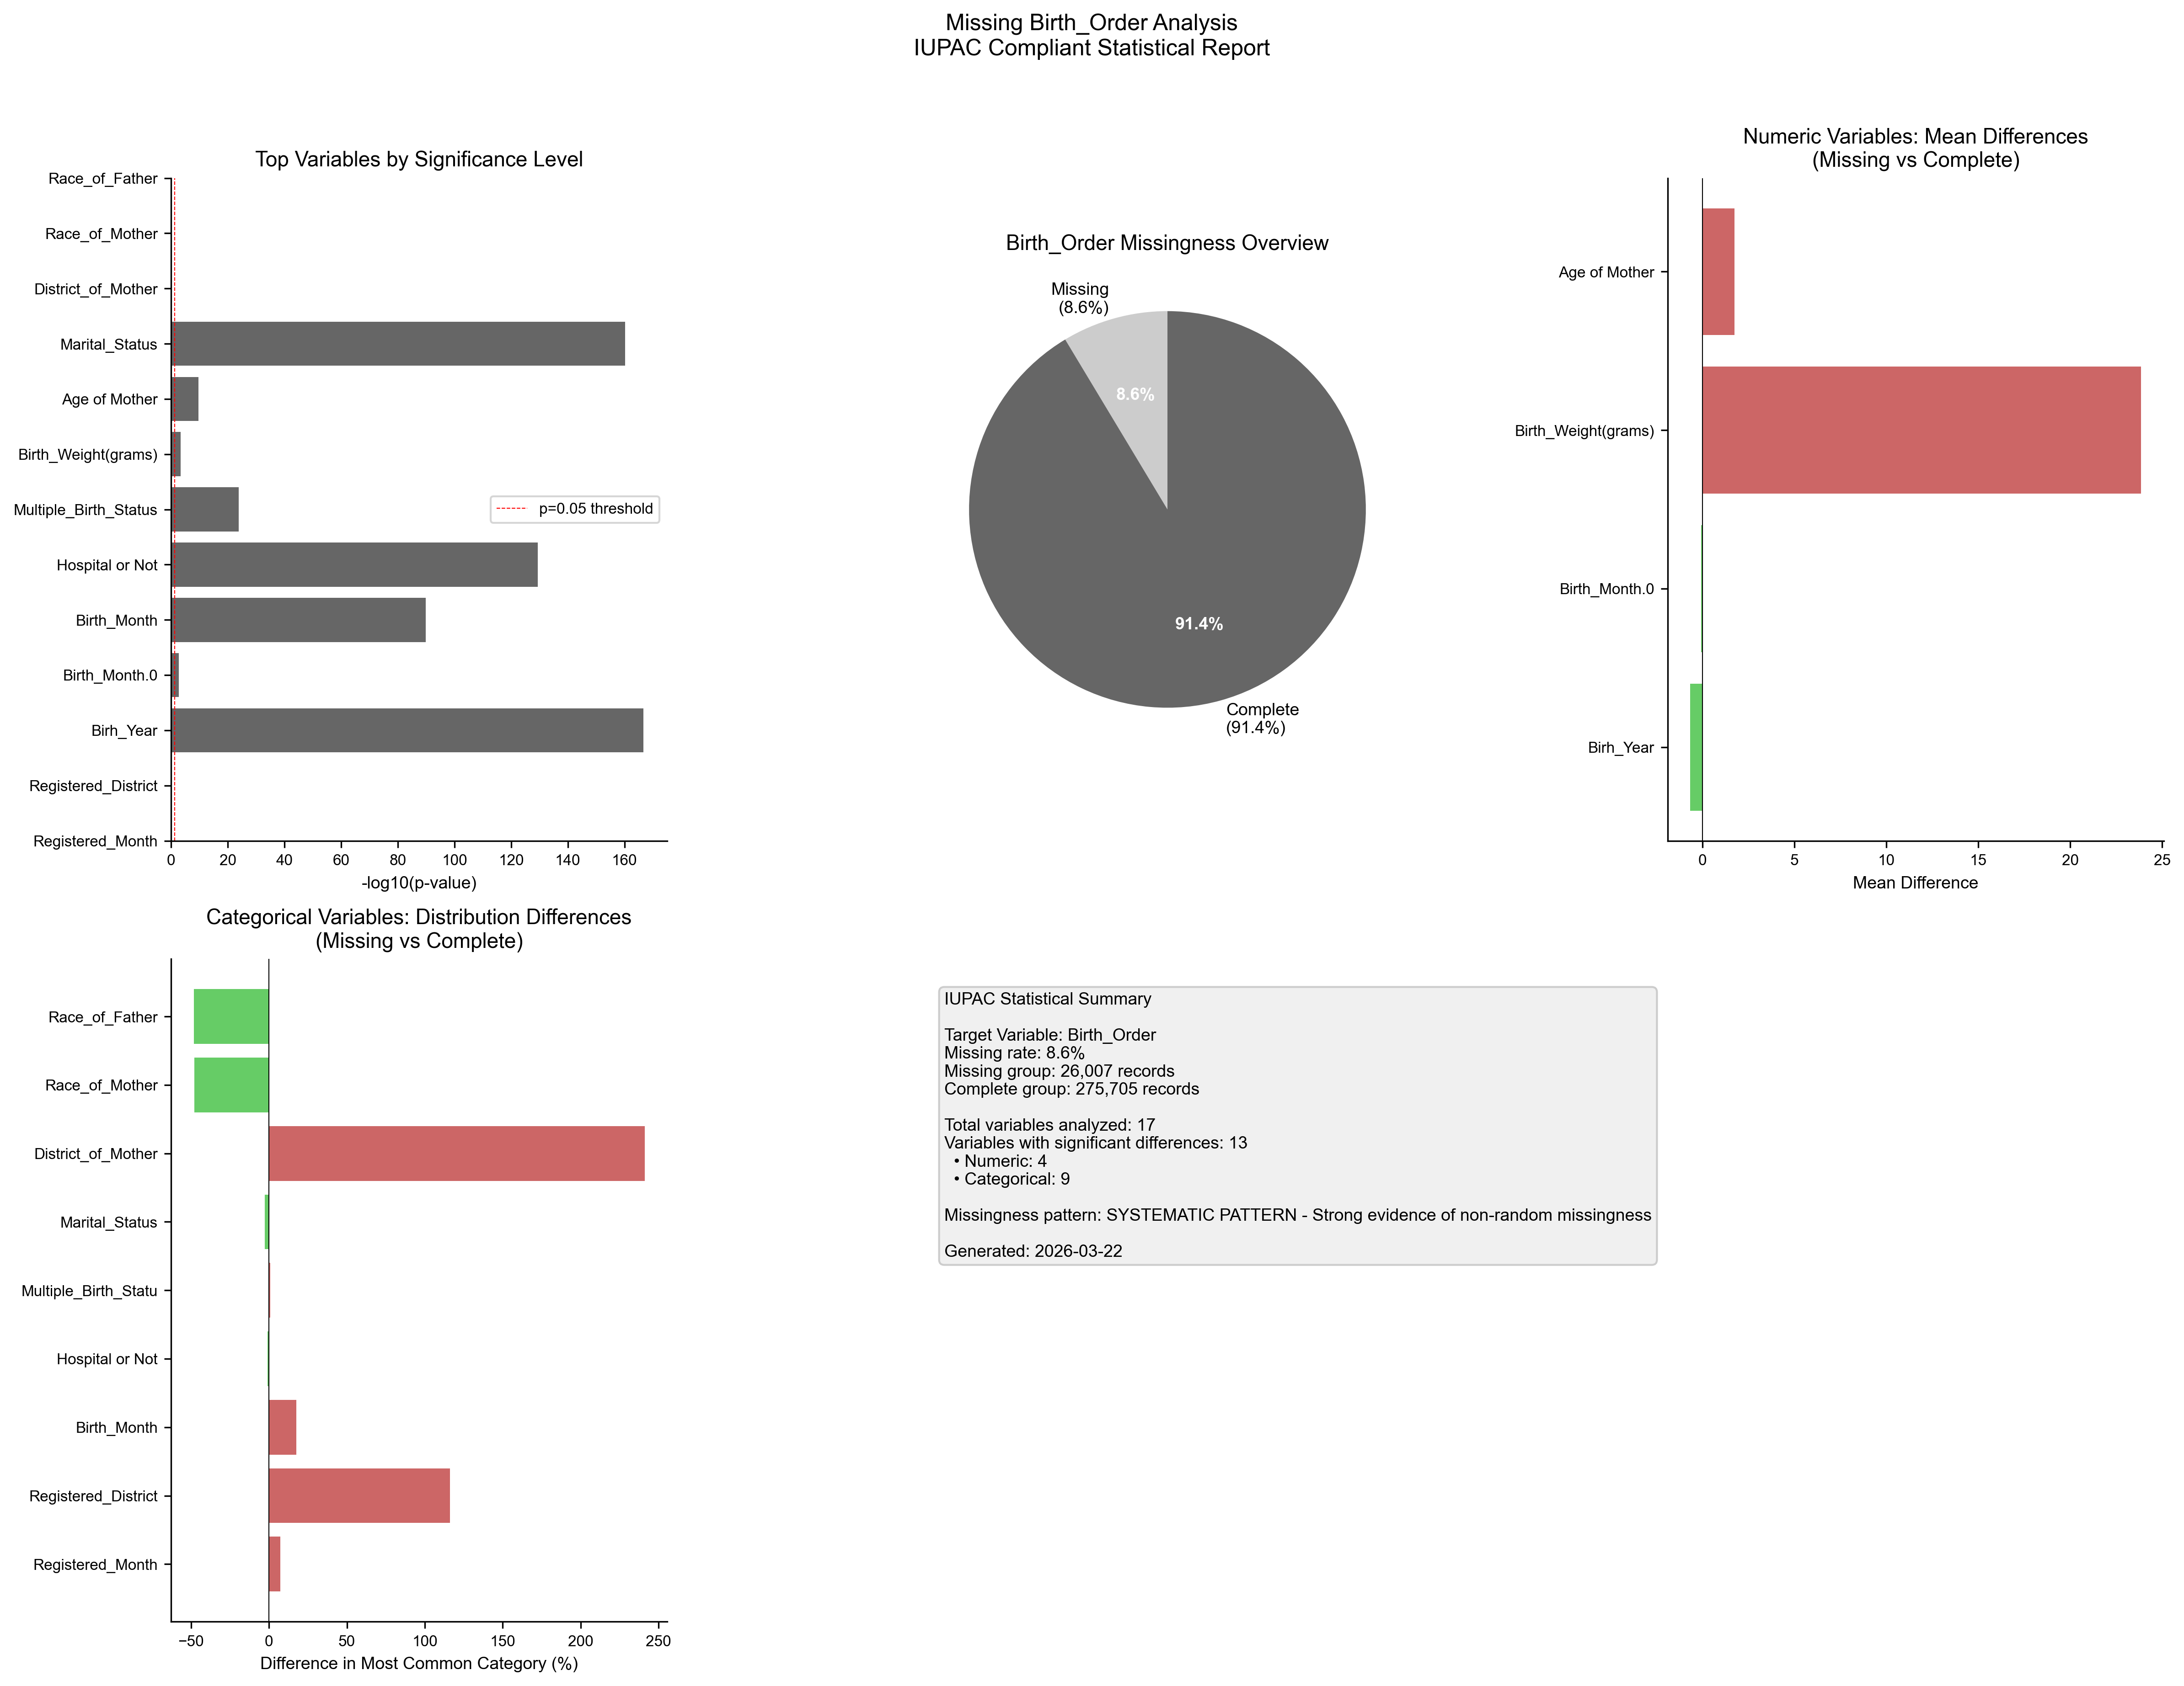
Figure 1. IUPAC compliant statistical visualization of missing Birth_Order patterns.

5. Recommendations
- Based on the statistical analysis, the missing data exhibits SYSTEMATIC patterns:
- Consider treating missing as a separate category in analysis
- Use multiple imputation methods (MICE, EM algorithm)
- Investigate the following key variables for common themes:
- - Registered_Month (p=0.0000)
- - Registered_District (p=0.0000)
- - Birh_Year (p=0.0000)
- - Birth_Month.0 (p=0.0018)
- - Birth_Month (p=0.0000)
- - Hospital or Not (p=0.0000)
- - Multiple_Birth_Status (p=0.0000)
- - Birth_Weight(grams) (p=0.0004)
- - Age of Mother (p=0.0000)
- - Marital_Status (p=0.0000)
- Document missingness patterns in methodology section

6. Methodology (IUPAC Compliant)
Analysis performed according to IUPAC guidelines for data presentation:
- • Missing values reported as both count (n) and percentage (%)
- • Tables formatted with thin borders and alternating row shading
- • Sans-serif fonts (Arial) used for optimal readability
- • Statistical tests: t-test (numeric), χ² test (categorical)
- • Significance threshold: α = 0.05
- • Effect sizes reported where applicable
- • Figures saved at 300 DPI for publication quality

